BIO 101 Lab 07: Measuring Cellular Respiration and Fermentation

Notification: If you have a disability that makes it difficult to complete this lab, please contact your instructor. Please provide your instructor a copy of the Memorandum of Accommodation (MOA) from NVCC Disability Support Services.

Objectives:____________________________________________________________
- Distinguish between anaerobic and aerobic respiration.
- Measure the rate of oxygen consumption by living organisms during aerobic cellular respiration.
- Calculate metabolic rate from the experimental data.
- Measure the rate of yeast fermentation.
Background:___________________________________________________________
All life requires energy to survive. The energy of glucose is used as fuel by nearly all living organisms to stay alive, to maintain homeostasis, and run all kinds of life activities. The energy stored in chemical bonds of glucose and other food molecules needs to be released and converted into a diffusible, usable form ATP. When oxygen is present, most living organisms prefer to use the aerobic respiration pathway because they can make more energy (ATP) than when they use the anaerobic pathway. However, living organism can also partially break down glucose in the process of anaerobic respiration to produce 2 ATP molecules from each glucose molecule when oxygen is not available.
Aerobic respiration can produce up to 38 ATPs per molecule of glucose as compared to the 2 ATP that are generated in the anaerobic pathway. The three major parts of aerobic respiration are 1) Glycolysis, 2) Krebs Cycle (Citric Acid Cycle), and 3) Electron Transport Chain (ETC) and oxidative phosphorylation. The overall equation of cellular respiration is:
C₆H₁₂O₆ + 6 O₂ → 6 CO₂ + 6 H₂O + 38 ATP
We can measure the rate of cellular respiration by measuring the consumption of the reactants (glucose or oxygen), or by measuring the rate of production of the end products (carbon dioxide or water) of this process. The easiest component to measure is oxygen consumption. If the living organism is placed in a closed system with the carbon dioxide removed as it is produced, then the consumption of oxygen can be determined using a respirometer. The respirometer consists of a glass container sealed with a rubber stopper outfitted with a pipette. A compound such as potassium hydroxide is placed in the respirometer to remove the carbon dioxide generated. As the living organism within consumes oxygen, water will displace the gas in the pipette and the volume of oxygen consumed can be measured over time to calculate the rate of cellular respiration and metabolic rate.
Anaerobic respiration is the incomplete break down of sugar. It produces lactic acid in animal cells and ethanol and carbon dioxide in yeast. Anaerobic respiration in yeast is also called fermentation, which is used to produce wine and bread, and more recently biofuels. Different sugars are used at different rates in yeast fermentation which can be measured by monitoring the production of carbon dioxide.

Materials:_____________________________________________________________

- Internet | - Calculator

Safety:

Follow all standard laboratory safety procedures. Be sure to wear gloves and use the forceps when working with potassium hydroxide.

Procedure:____________________________________________________________

Experiment 1. Cellular respiration

- Watch the following video about the cellular respiration lab from time 0:00 until 4:25.
https://www.youtube.com/watch?v=r9o_VdToClE&t=224s
Ignore the use of worms and the use of glass beads in the video, we don’t use those in this lab activity.

- Watch the following video about setting up a respirometer from time 3:38 until 9:42.
https://www.youtube.com/watch?v=oL7C9_3biZQ
Ignore the use of glass beads in the video, we don’t use those in this lab activity.
As oxygen is consumed by the organisms, water will start to enter the pipettes. See the image below for a depiction of the respirometer setup.

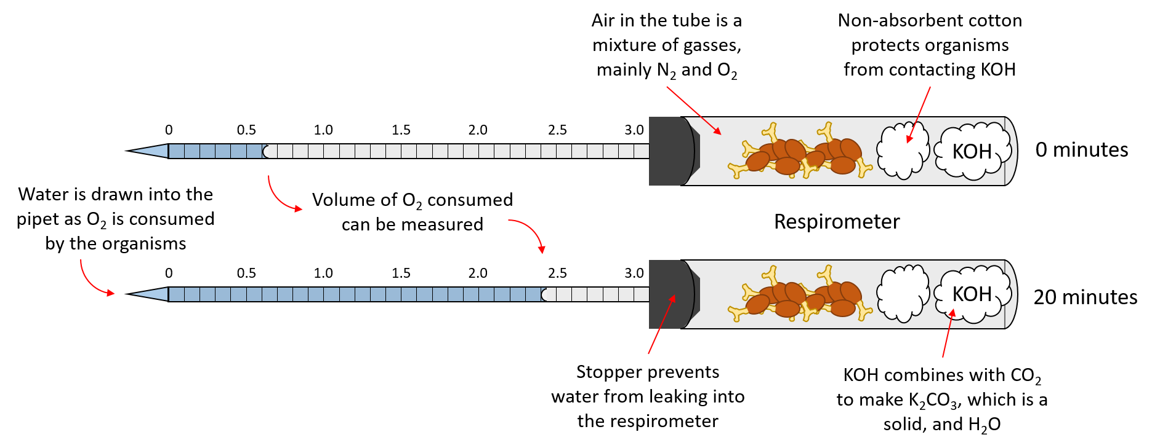

- Using the results diagrammed below, determine the amount of oxygen consumed in 20 minutes in Respirometer A and Respirometer B by measuring the volume of water that has entered the pipette at time = 20 minutes and subtracting the amount of water that was present in the pipette at time = 0 minutes. Enter your results in Table 1 in the Lab Worksheet.

For example, if the amount of water in the pipette at time = 0 minutes was 0.5 mL and the amount of water in the pipette at time = 20 minutes was 0.8 mL, then the amount of oxygen consumed in 20 minutes would be equal to 0.8 mL – 0.5 mL = 0.3 mL
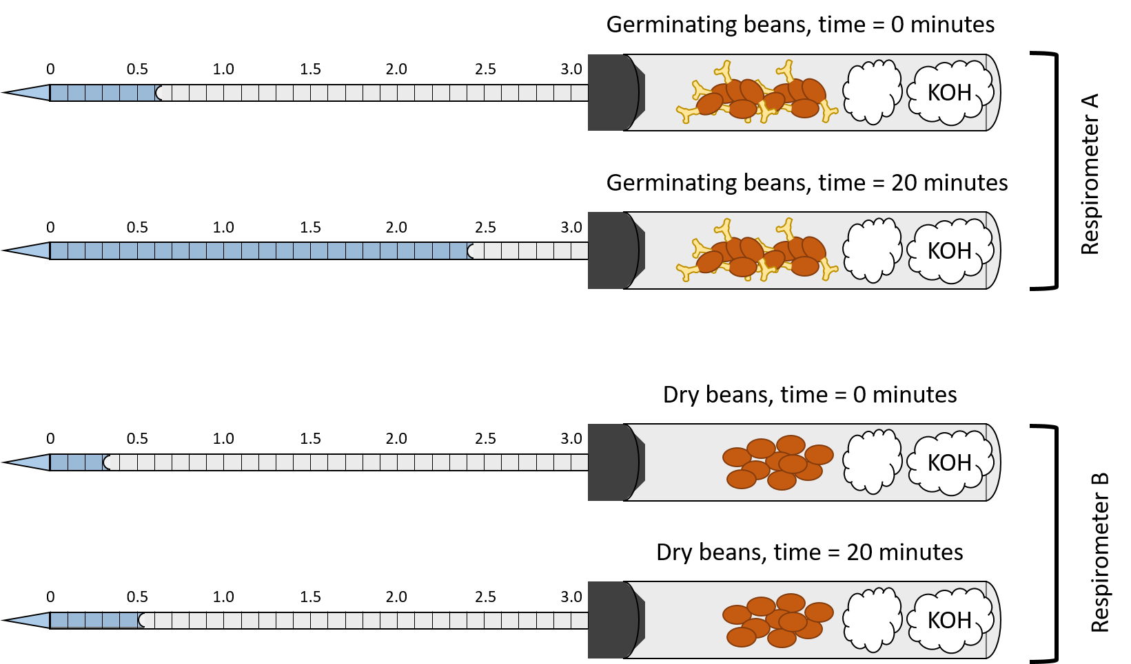

- Next, convert the metabolic rates for the Germinating Beans and the Dry Beans from the number of mL O₂ consumed in 20 minutes into the number of mL O₂ consumed in 1 hour. Enter your results in Table 1 in the Lab Worksheet.

For example, if the amount of O₂ consumed in 20 minutes is 0.3 mL, then the amount of O₂ consumed in 1 hour would be 0.9 mL because there are 60 minutes in 1 hour.

- Answer questions 1-4 on the Lab Worksheet.

Experiment 2. Yeast fermentation
- Watch the following video about setting up yeast fermentation tubes and measuring the height of the bubble at the top of the tubes from time 0:00 until 1:30 and from time 2:05 until 2:25.
https://www.youtube.com/watch?v=YVqVBCnNgVA

- In the laboratory, you would obtain and label four small test tubes from 1 to 4. You would then fill them half full with the following solutions:

Tube 1 | Glucose solution
Tube 2 | Fructose solution
Tube 3 | Sucrose solution
Tube 4 | Deionized water

- After putting the solutions into the test tubes, you would then fill all four tubes to the top with yeast suspension.

- Using the results diagrammed below, fill in Table 2 in the Lab Worksheet

First, measure the height of the air bubble (in millimeters) in each tube at the Initial gas height and the Final gas height times and record your measurements in Table 2 in the lab worksheet.
Then, determine the amount of carbon dioxide produced by yeast fermentation in each of the tubes by subtracting the height of the air bubble at the Initial gas height time from the height of the air bubble at the Final gas height time. Enter your results in Table 2 in the Lab Worksheet.
For example, if the height of the air bubble at the Final gas height time is 25 mm and the height of the air bubble at the Initial gas height time is 5 mm, then the change in height, which corresponds to the amount of CO₂ produced, is 25 mm – 5 mm = 20 mm.

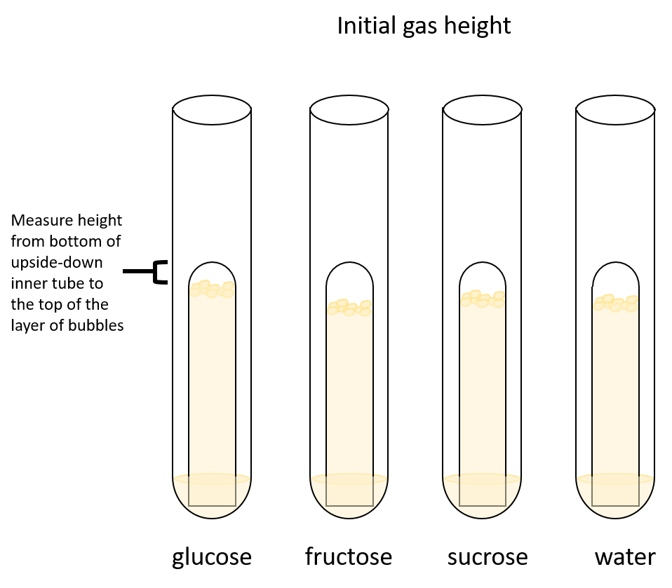
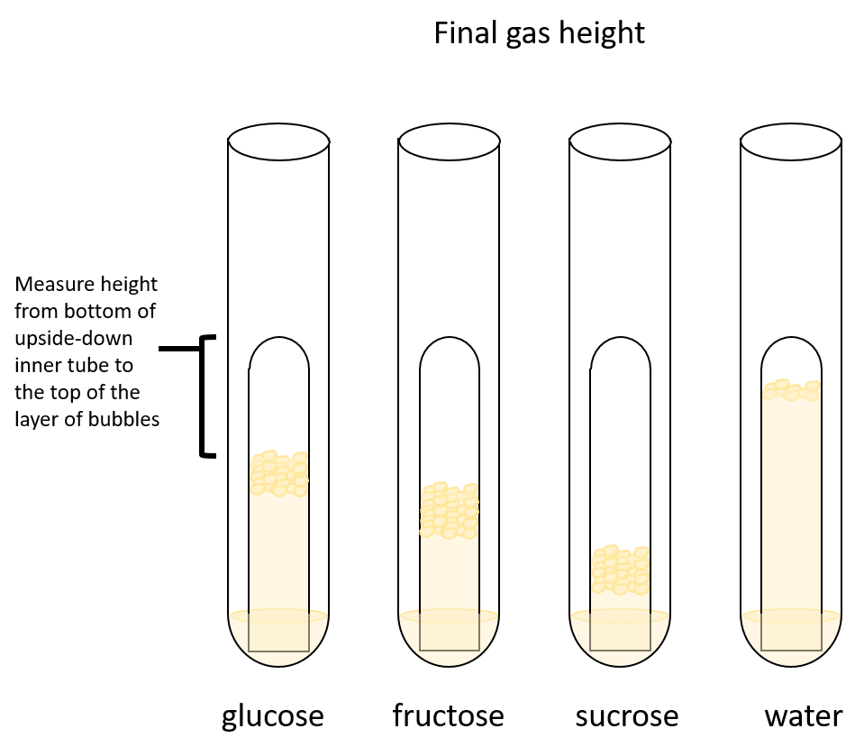

- Answer questions 5-7 in the Lab Worksheet.
BIO 101 Lab 07: Cellular Respiration & Fermentation Worksheet

Name: __________________________ Section: ______________________

Data Analysis and Synthesis Questions:___________________________________

Table 1. Calculate the metabolic rates

Respirometer | Contents | Oxygen consumption  (ml O₂/20 min) | Oxygen consumption  (ml O₂/hr)
A | Germinating beans | 1.8 | 5.4
B | Dry beans | 0.2 | 0.6

- What is the independent variable for the cellular respiration experiment?

The independent variable for the cellular respiration experiment is the germinating beans and dry beans.

- What is the dependent variable for the cellular respiration experiment?

The rate at which the respiration occurs

- Explain why water moved into the respirometer

During the respiration process, oxygen was used up and carbon dioxide was released. The carbon dioxide produced was absorbed by the potassium hydroxide leaving a vacuum and that is the water was sucked to occupy the space.

- If you increase the temperature of the water bath that the respirometer was in, what would you predict would happen to the rate of cellular respiration in the germinating beans?

The rate of cellular respiration will increase with increase in temperature until the optimum temperature is reached. Beyond the optimum temperature the rate of cellular respiration gradually slows down and finally stops since the enzymes are denatured.

Table 2. Yeast fermentation

Tube | Sugar | Initial gas height (mm) | Final gas height (mm) | Change in height (mm)
1 | glucose | 3 | 14 | 11
2 | fructose | 6 | 18 | 12
3 | sucrose | 5 | 26 | 21
4 | water | 5 | 5 | 0

- What is the independent variable for the yeast fermentation experiment?

The independent variable is sugar.

- What is the dependent variable for the yeast fermentation experiment?

The dependent variable is the change in gas height

- Which sugar resulted in the fasted production of CO2 gas? What is your explanation for this observation?

Sucrose had the fasted production of CO₂ because it gave the biggest change in height. This is because the fermentation occurred and the carbon dioxide produced gave the change in height which was largest among the four tubes.

